111-40-10100
Water Body Name: Lemon Creek
Species & Lifestage Observed: Ks,p
Observation Date: 8/26/2025
Species Addition
HUC12: 190103010605
MTR: C040S066E
Quad: JUNEAU B-2 SE

Observers: Luke Brockmann
Observations: I captured 2 adult king salmon with sportfishing gear. I recorded the coordinates of the capture location on a smartphone app. Observation locations and notes in Table 1, fish photos and a map of 111-40-10100 with observation point in Figures 1-3.
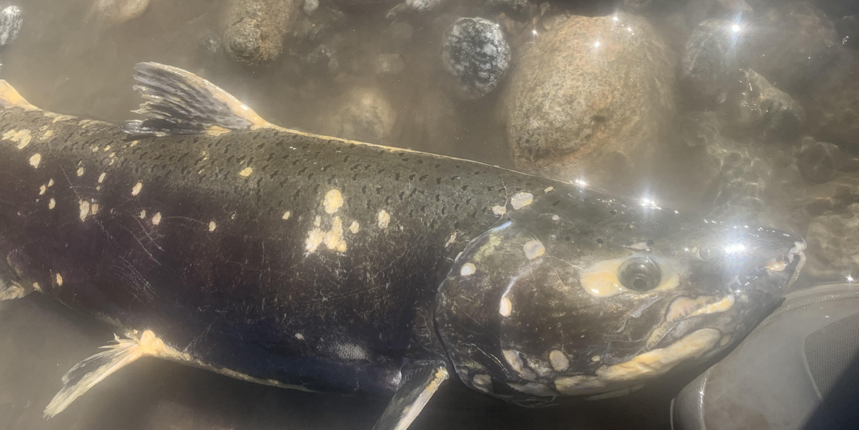
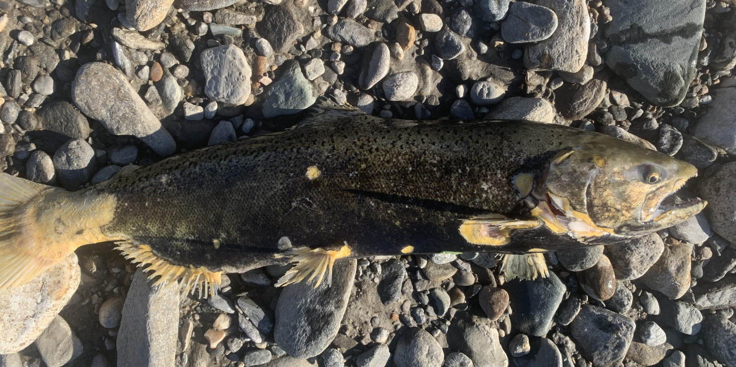
Table 1.- 111-40-10100 observation locations and notes.
Figure 2.- Second adult king salmon captured at waypoint 1.
Figure 1. - Adult king salmon captured at waypoint 1.
Waypoint | Latitude | Longitude | Notes | Sample Effort | Sample Result
1 | 58.360027 | -134.485839 | Two king salmon angled from Lemon Creek | Rod and reel | 2 K
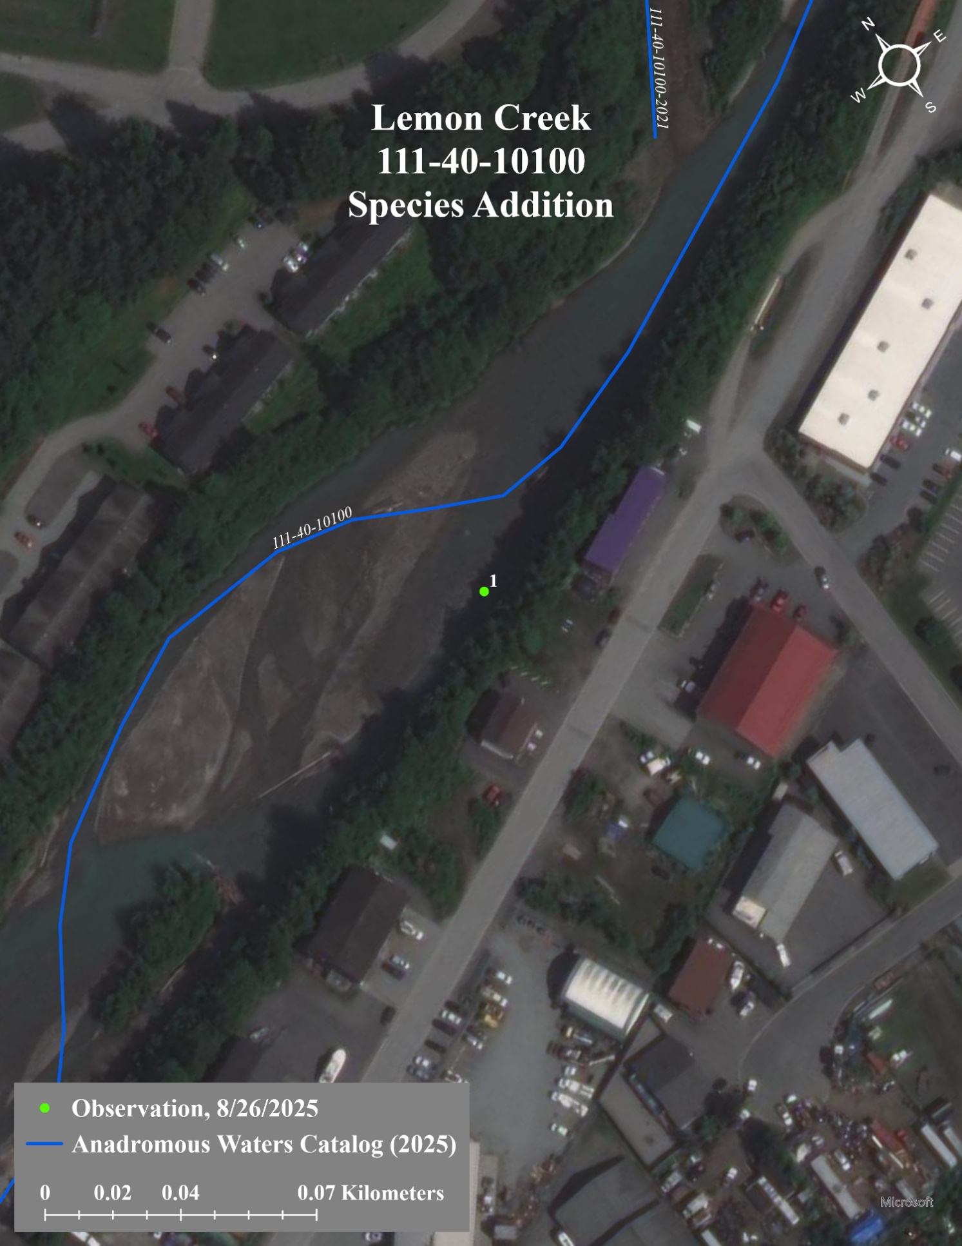
Figure 3.- A map of 111-40-10100 showing observation location.

